For CPE performance: Re-association

Check which operations can be precomputed for the next iteration.

R = R\*(x\*(y\*z)) achieves latency\*1/3

R = (R\*x) \* (y\*z) achieves \*2/3

Performance improvement techniques:

* High-level design—Choose appropriate algorithms and data structures
* Basic Coding Principles: Avoid optimization blockers
  + Eliminate excessive function calls. Move computation out of loops when possible. Consider compromises of program modularity for efficiency.
  + Eliminate unnecessary memory references. Introduce temporary variables to hold intermediate results. Only store in array or global variable after computing final value.
  + Watch for MEMORY ALIASING
* Low-level Optimizations: Structure code to take advantage of hardware
  + Unroll loops to reduce overhead and enable further optimization
  + Find ways to increase instruction-level parallelism by using techniques like multiple accumulators or reassociation.
  + Rewrite conditional operations in a functional style; enables compilation using cmov
    - Long Tempa = a[i], tempb = b[i];
    - Long take1 = a[i]<b[i];
    - min = (take1) ? Tempa : tempb;

Floats are usually NORMALIZED (look at first 1 bit and take it as implied)

Code flow diagram

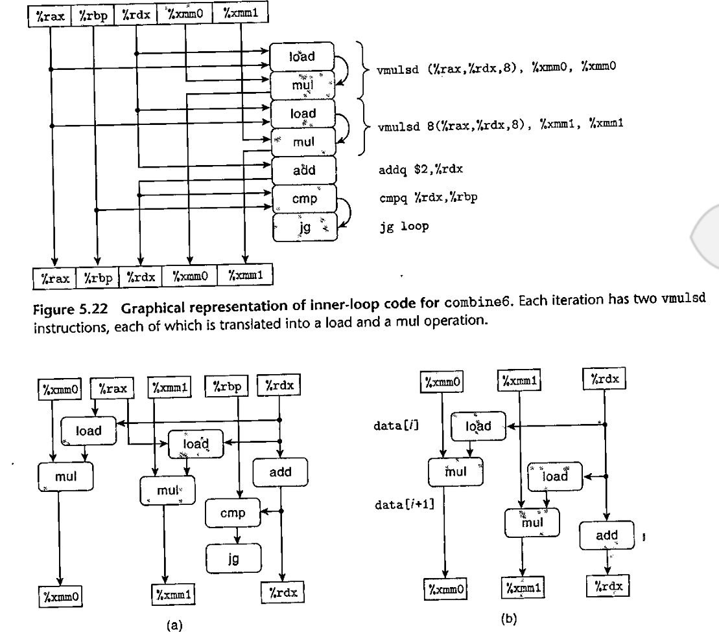

Intel Corei7 Haswell reference machine has 8 functional units. Partial list of each’s capabilities:

1. Integer arithmetic (addition bitwise ops and shifting, not mult and div), float mult, integer and float division, branches
2. Integer arithmetic, float add, integer mult, float mult
3. Load, address computation
4. Load, address computation
5. Store
6. Integer arithmetic
7. Integer arithmetic, branches
8. Store address computation (store op requires 2 functional unit)

